**DNN LISTENER**

We have seen how to create a VNN listener in the previous notes.

At this point it is assumed that we have the cluster built and an AG role created in the cluster. There is no need to create a listener from SSMS (do not create one).

DNN is configured differently than VNN. Note the following:

* You use a Microsoft PowerShell script and supply ***3 parameters*** (AG, DNS, PORT).
* DNN **doesn’t need Load Balancer**. Therefore, there is no need to build load balancer with frontip and backend pool.
* It requires **a port other than 1433** e.g. 6789 else it could fail.
* Port can be any port number e.g. 59999 or 49999
* DNN works with **applications that accept “Multisubnetfailover=true”** parameter. Some **OLD or legacy** .net based applications may not have this capability hence it is preferable to create a listener using **VNN/Load balancer** in such scenarios. Please follow [Microsoft’s guide](https://learn.microsoft.com/en-us/azure/azure-sql/virtual-machines/windows/availability-group-vnn-azure-load-balancer-configure?view=azuresql&tabs=ilb) on how to change RegisterAllProvidersIp and HostRecordTTL settings
* You can create a DNN listener **in addition to an existing** VNN listener, and both can function together.
* Run the PowerShell script on the **primary**.
* **A DNN listener does not have a single static IP like a VNN listener**. Therefore, you **will not see an associated IP for the listener in SSMS**. However, the DNN listener name can be viewed from the DNS server, and it binds to the IP addresses of the active nodes (the two nodes in our case).
* **The three parameters**: 1) AG = the AG name e.g. ProdAG which we create previously. 2) DNS = the Listener name which we want to have e.g. PRODAGDNN. 3) Port – a port number other than 1433 e.g. 6789. **The port number should be added to the firewall rule** of VMs.

**Step 1: Copy paste the PowerShell script and run**

Source: [Configure DNN listener for availability group - SQL Server on Azure VMs | Microsoft Learn](https://learn.microsoft.com/en-us/azure/azure-sql/virtual-machines/windows/availability-group-distributed-network-name-dnn-listener-configure?view=azuresql)

param (

[Parameter(Mandatory=$true)][string]$Ag,

[Parameter(Mandatory=$true)][string]$Dns,

[Parameter(Mandatory=$true)][string]$Port

)

Write-Host "Add a DNN listener for availability group $Ag with DNS name $Dns and port $Port"

$ErrorActionPreference = "Stop"

# create the DNN resource with the port as the resource name

Add-ClusterResource -Name $Port -ResourceType "Distributed Network Name" -Group $Ag

# set the DNS name of the DNN resource

Get-ClusterResource -Name $Port | Set-ClusterParameter -Name DnsName -Value $Dns

# start the DNN resource

Start-ClusterResource -Name $Port

$Dep = Get-ClusterResourceDependency -Resource $Ag

if ( $Dep.DependencyExpression -match '\s*\((.*)\)\s*' )

{

$DepStr = "$($Matches.1) or [$Port]"

}

else

{

$DepStr = "[$Port]"

}

Write-Host "$DepStr"

# add the Dependency from availability group resource to the DNN resource

Set-ClusterResourceDependency -Resource $Ag -Dependency "$DepStr"

#bounce the AG resource

Stop-ClusterResource -Name $Ag

Start-ClusterResource -Name $Ag

* 1. **Supplying Parameter values**

Once you copy and paste the PowerShell script and run it, it will ask for three parameters consecutively for you to supply: supply the values and hit enter

1. **AG** – **supply AG name e.g. ProdAG**

1. **DNS – the DNN listener name we want to have**

e.g. PRODAGDNN or PRODDNNLISTENER, DNNLSNR…etc

**C. PORT – use port number other than 1433**

After you supply the last parameter and hit enter

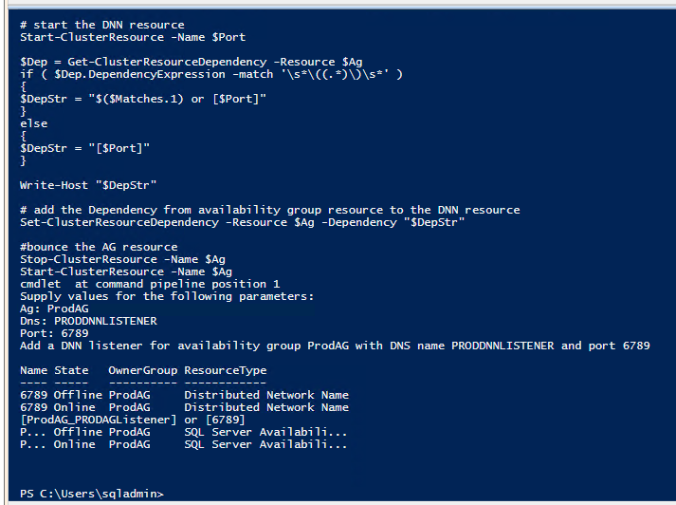

**Step 2: check the DNN listener is created**

* It has **no IP.** **If the port number doesn’t exist, add the port you used in the powershell and save.**

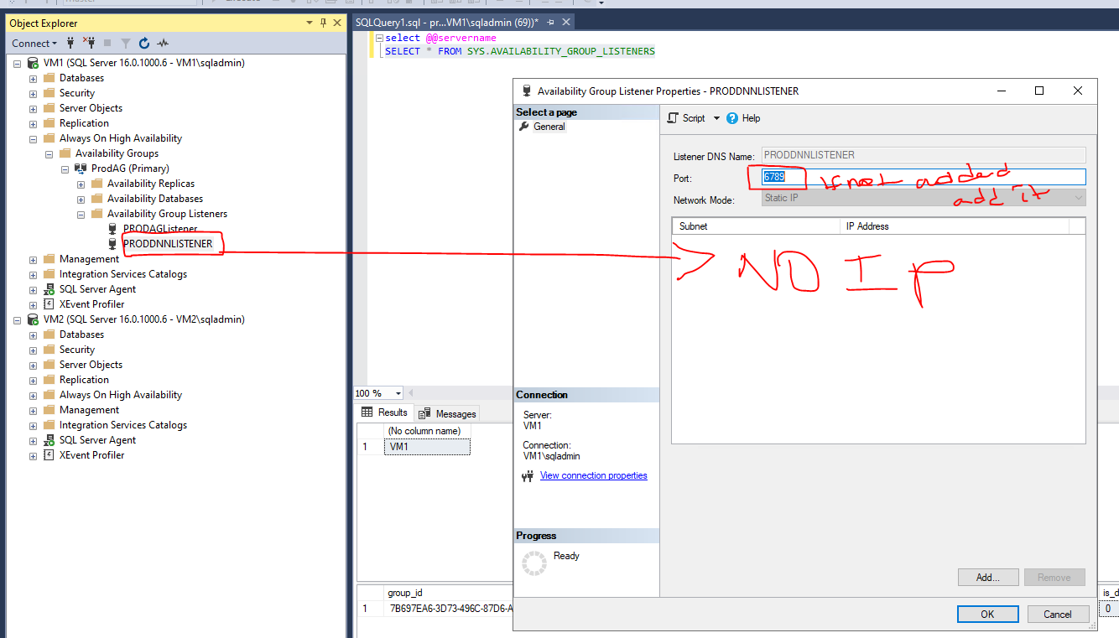

**Step 3: Add the port number in the firewall rule of VMs.**

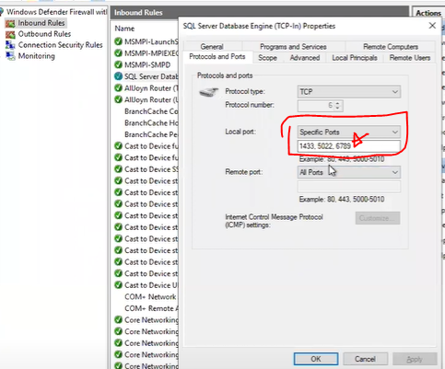

**Step 4: make sure the Dependency is created in the AG (this is done automatically by default).**

Checking from SSMS if distributed network name is created, if yes 1, if no (for VNN) 0.

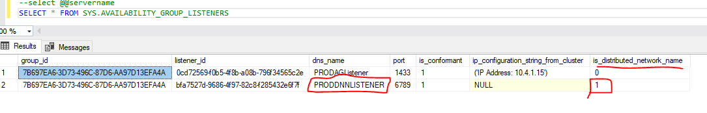

**Final**

**Step 5: Connection**

* Initial connection might take few seconds to minutes after the creation of the listener. So don’t worry if it fails immediately after you create the listener and configure the ports. Wait for few minutes.
* You can connect using the listener without adding the port number. But if it fails, add the port number after the DNN listener. E.g. PRODDNNLISTENER or PRODDNNLISTENER, 6789